**Project Design Phase-II**

**Technology Stack (Architecture & Stack)**

|  |  |
| --- | --- |
| Date | 16 October 2022 |
| Team ID | **PNT2022TMID43073** |
| Project Name | Project - Customer Care Registry |
| Maximum Marks | 4 Marks |

**Technical Architecture:**

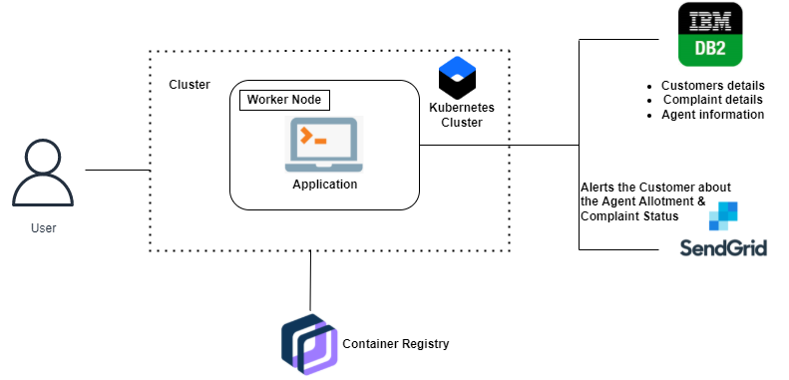

**Table-1: Components & Technologies:**

|  |  |  |  |
| --- | --- | --- | --- |
| **S No** | **Component** | **Description** | **Technology** |
|  | User Interface | The user interacts with the Web UI (Login form, Signup form, Dashboard, Ticket status, Forget password page), chat bots  (IBM Watson Assistant) | HTML, CSS, JavaScript |
|  | Login Logic | The customer / agent enters their email and password, and their respective roles and click on the Login button. The data entered is collected and checked and verified for the corresponding entry in the IBM DB2 database. If everything is correspondence with the data in the IBM DB2, customer / agent logs in. | HTML forms, Python, SQL, IBM DB2 |
|  | Register Logic | Customers registers in the application with their name, email, mobile number and password. The data entered is collected and stored in the IBM DB2 database. Once it is done, the customer is redirected to the Login page. | HTML forms, Python, SQL, IBM DB2 |
|  | Agent Creation Logic | Admin creates an agent with the following credentials. Name, email, mobile, gender, username, password. The data is collected and stored in the database. | HTML forms, Python, SQL, IBM DB2 |
|  | Ticket Creation Logic | Customer creates a new ticket in his dashboard, with the detailed description of his/her query (max of 150 characters).  This ticket is then stored in the database with a unique ID and a foreign key as the customer ID. | HTML forms, Python, SQL, IBM DB2 |
|  | Agent Assigning Logic | Agent sees all the newly created tickets in his/her dashboard. Agent then goes on to assign an agent for each ticket. The ticket status is updated in the IBM DB2 and then the customer who raised that ticket is notified through mail that as agent has been assigned. | HTML forms, Python, SQL, IBM DB2, SendGrid |
|  | Cloud Database | Stores all the details. Customer details, Agent details, Admin details, Ticket details. | IBM DB2 database |
|  | Object Storage | Stores some images in buckets. Used to display static images in the application. | IBM Cloud Object Storage |
|  | Chatbot (External API) | Used to guide customers, agents while logging in. Also, helps the customers while raising a ticket. Agents / Customers can interact with the chatbot and act right. | IBM Watson Assistant API |
|  | SendGrid (External API) | Used to notify the customers that an agent has been assigned for their raised ticket. Also, for the agents and customers while resetting their passwords. | SendGrid API, Python |

**Table-2: Application Characteristics:**

| **S No** | **Characteristics** | **Description** | **Technology** |
| --- | --- | --- | --- |
| 1. | Open-Source Frameworks | Flask micro-web framework | Python, Jinja, WSGI |
| 2. | Security Implementations | * All passwords are encrypted * Access control is implemented using Login Manager in Flask * Roles are defined in the SQL to prevent data manipulation and access | SHA-256 encryption, Flask, SQL |